DevOps End-to-End Deployment using CircleCI and Kubernetes

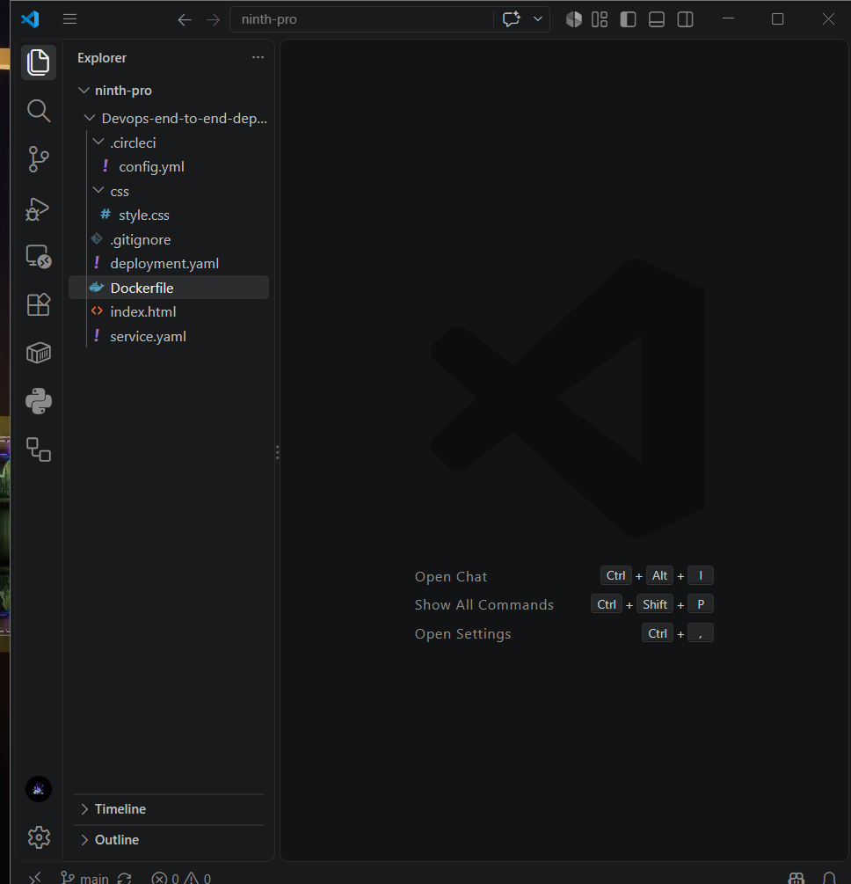

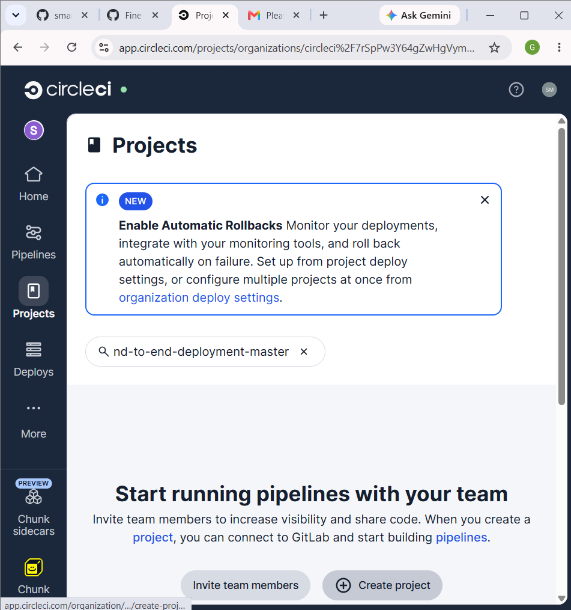

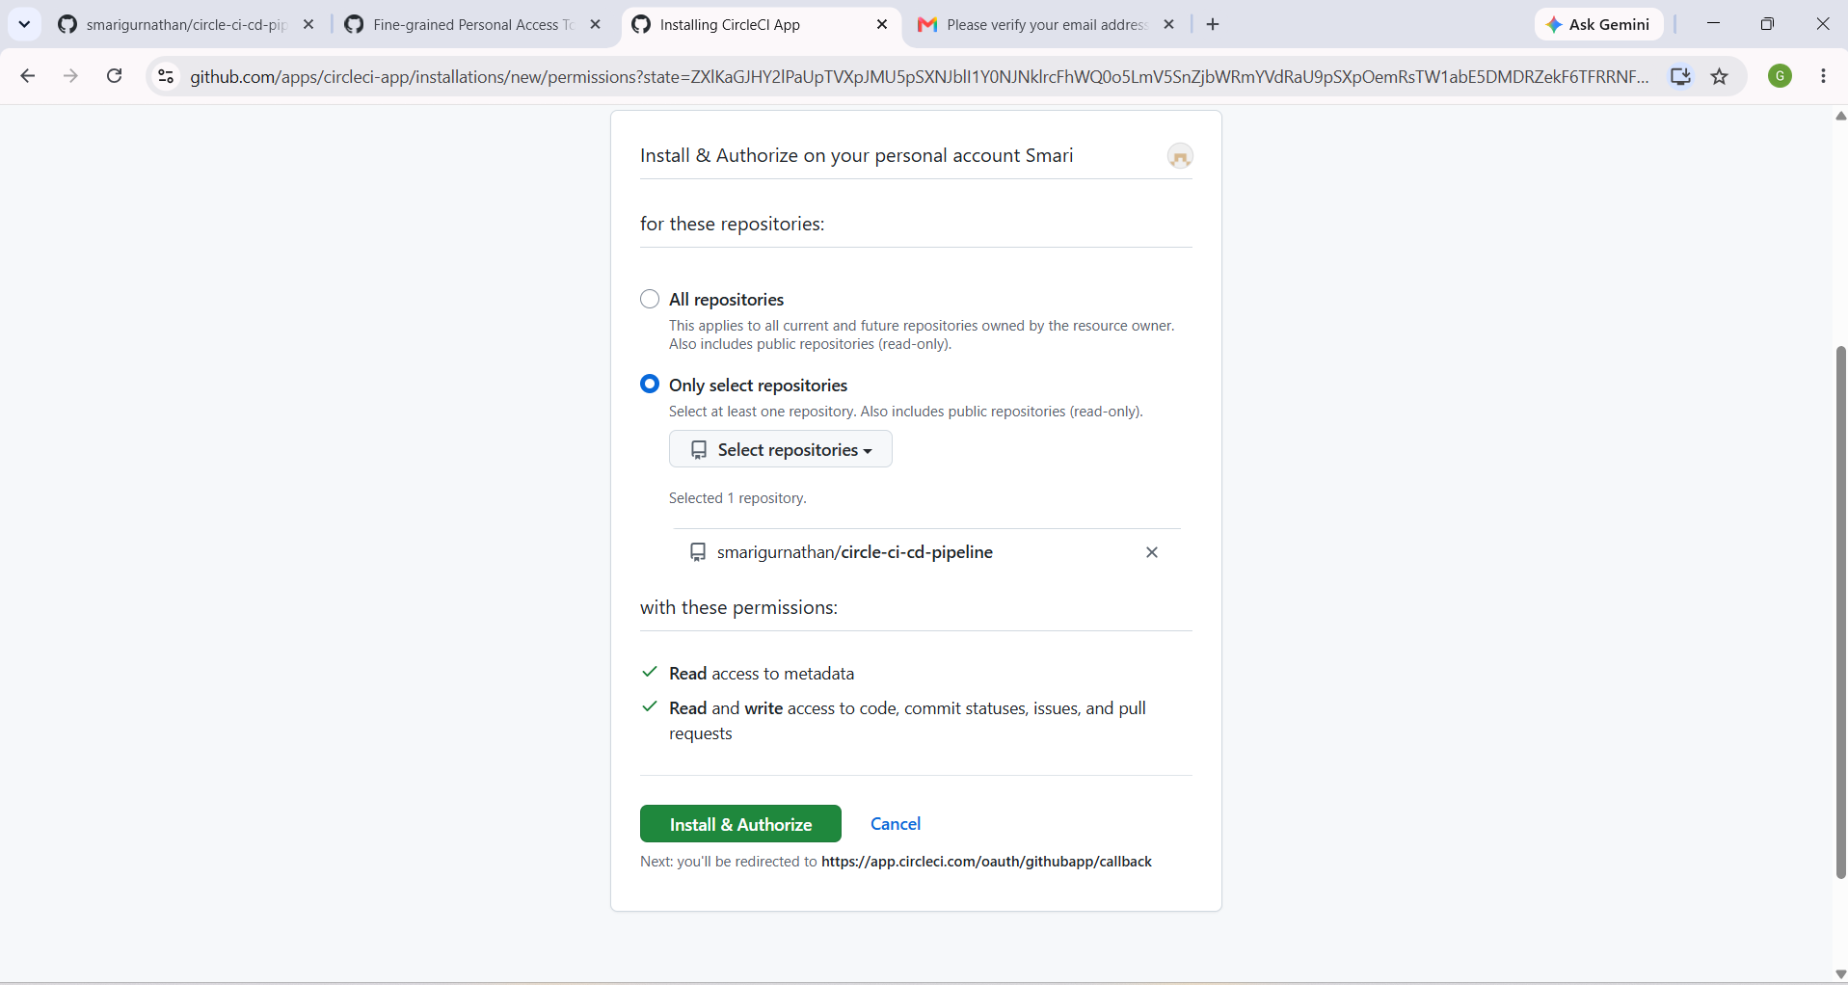

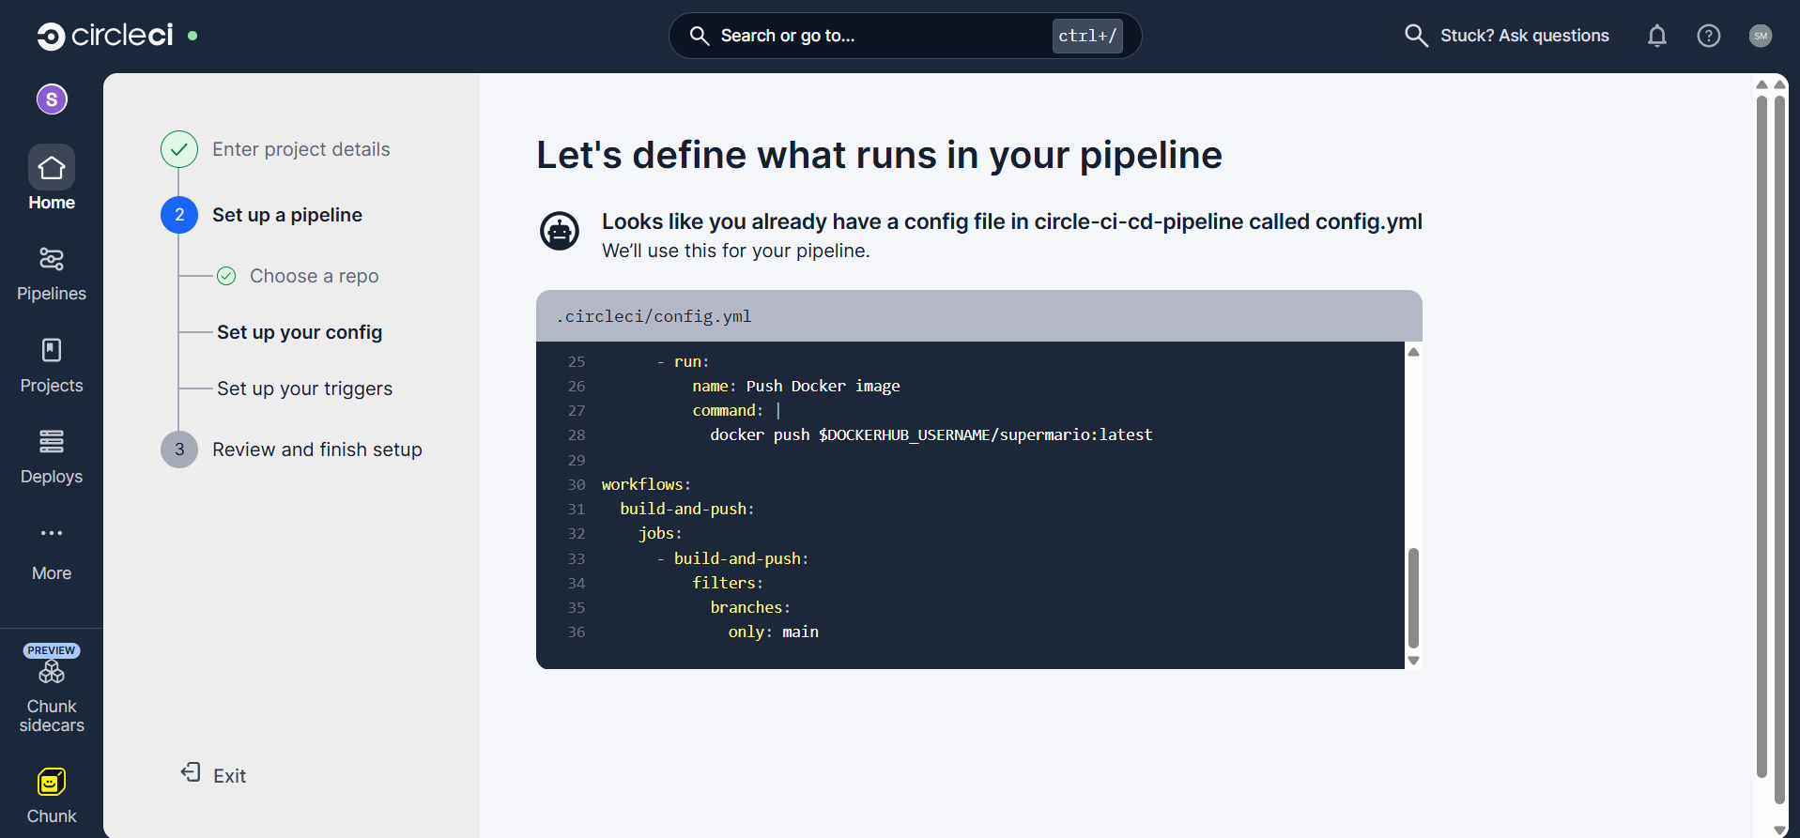

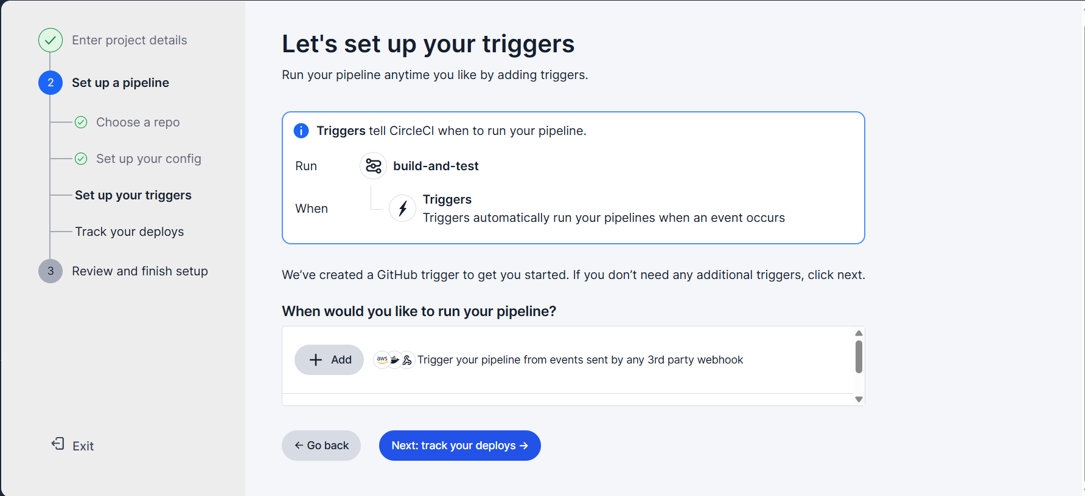

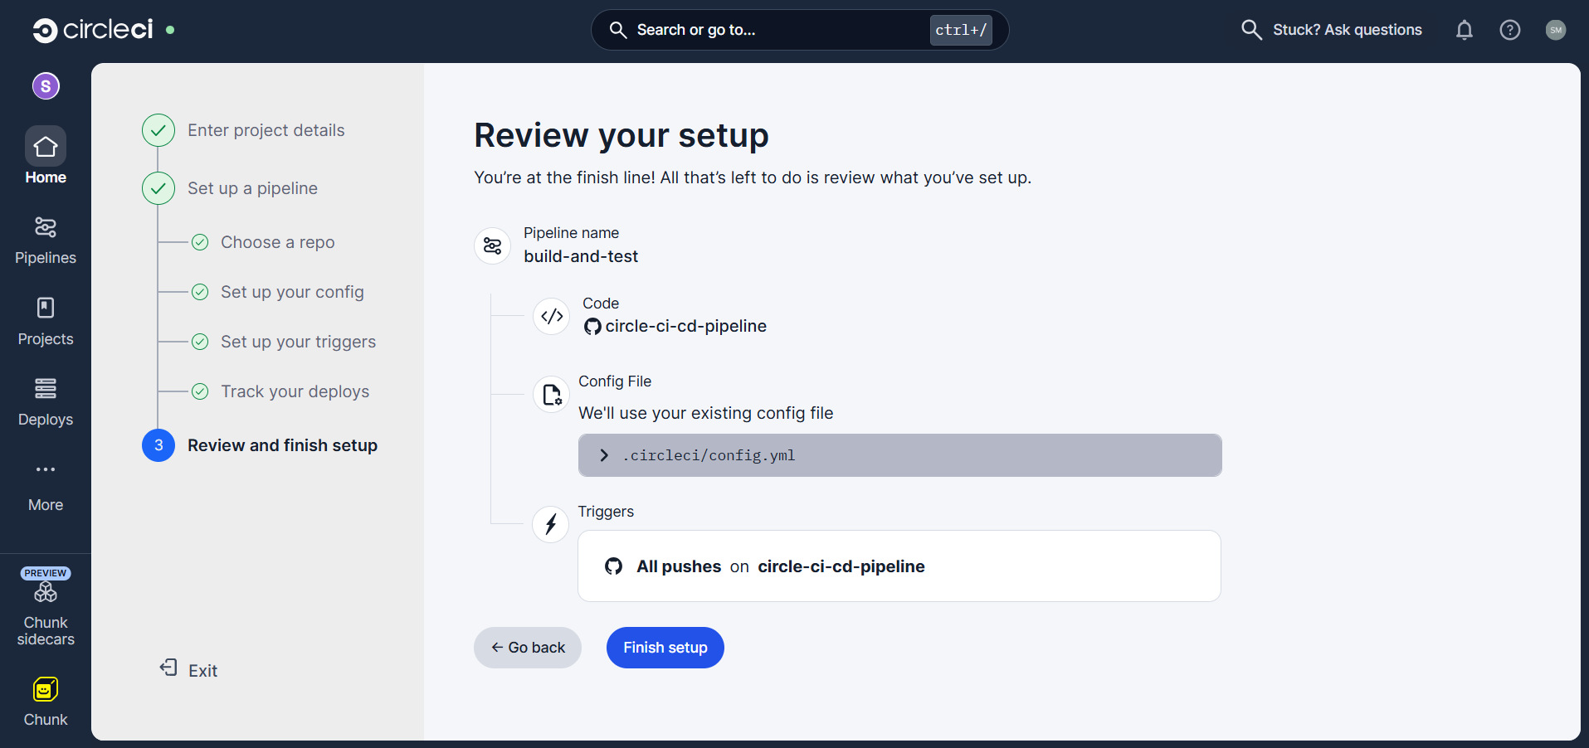

docker login -u santhanamarig

Set docker username and pwd in env variable

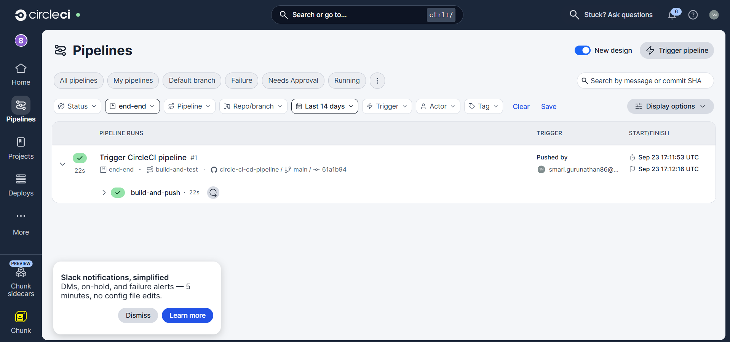

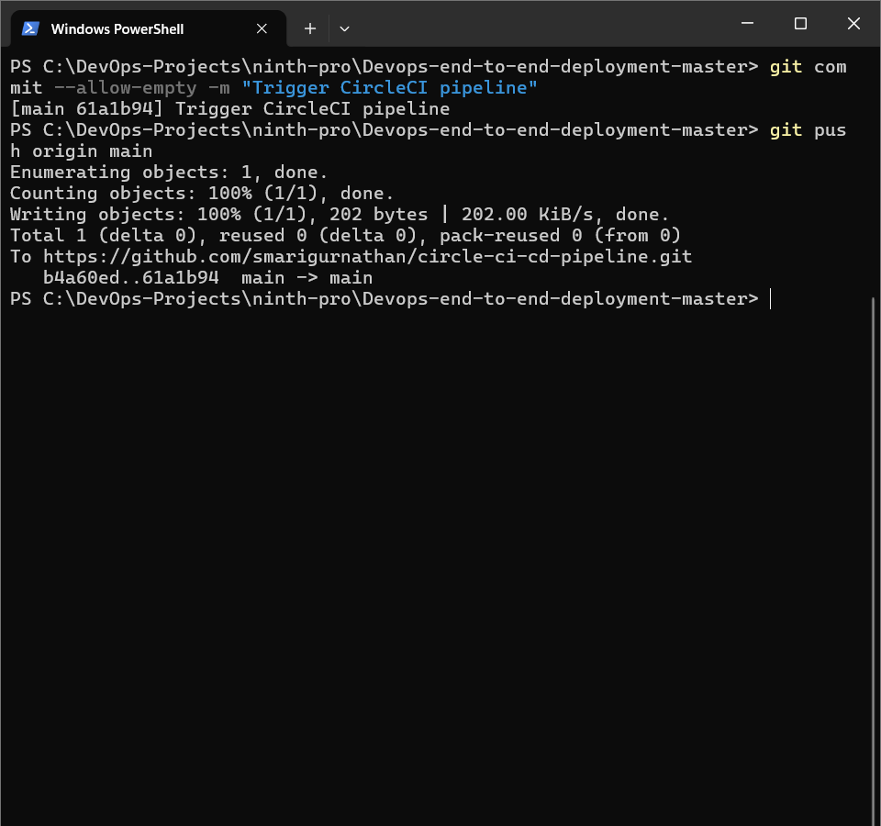
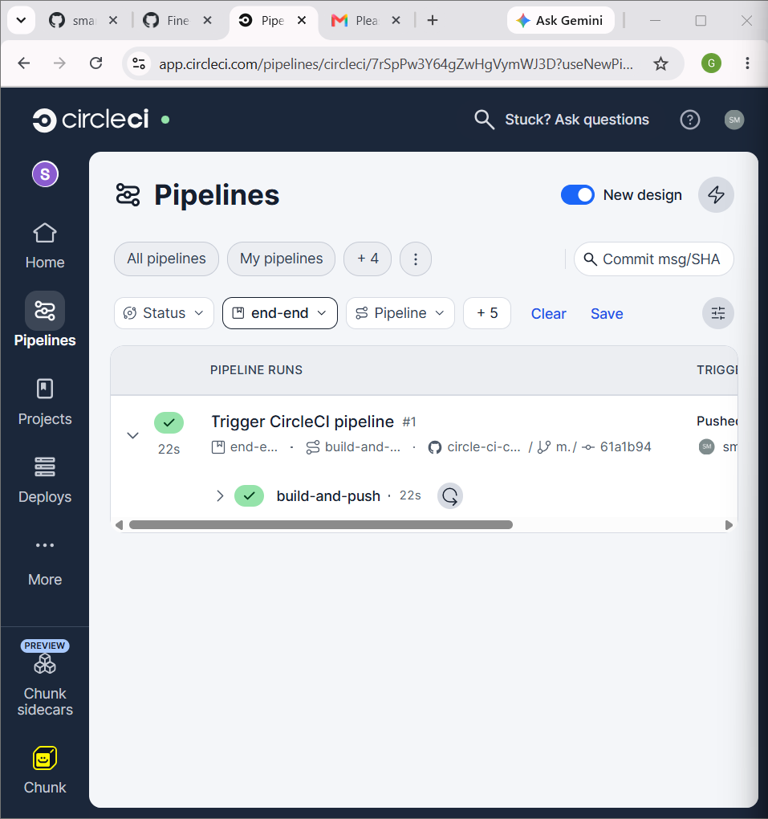

circleci
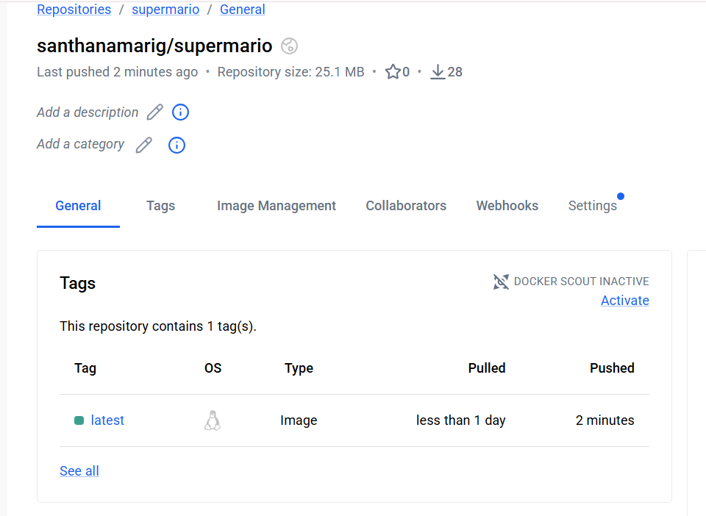

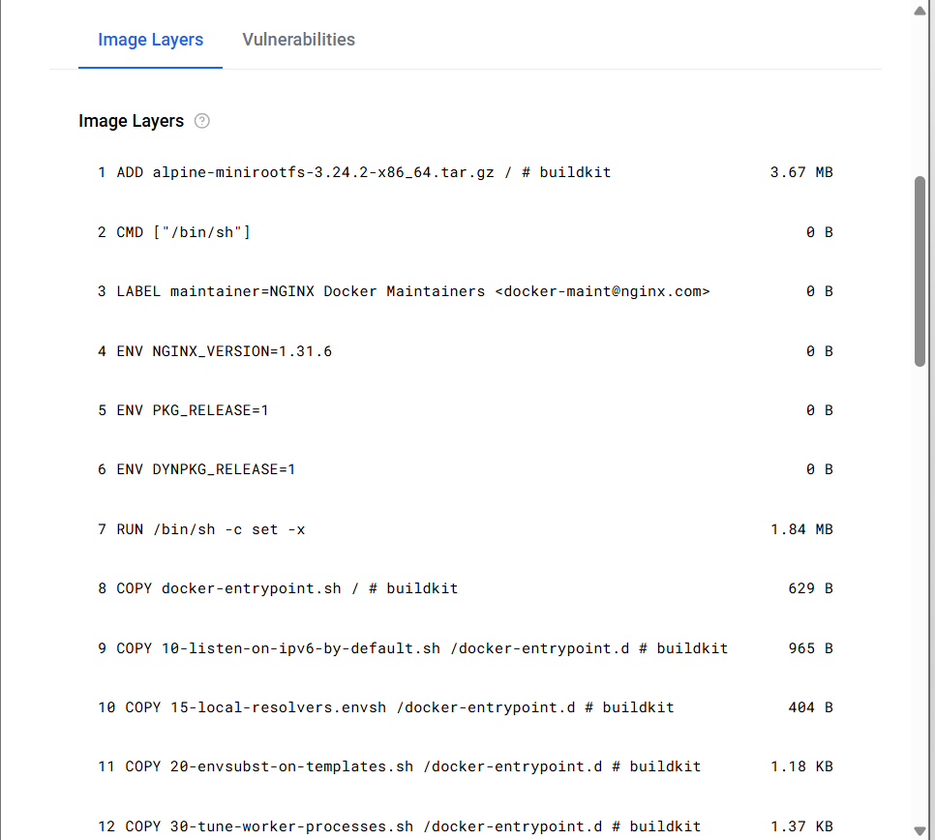

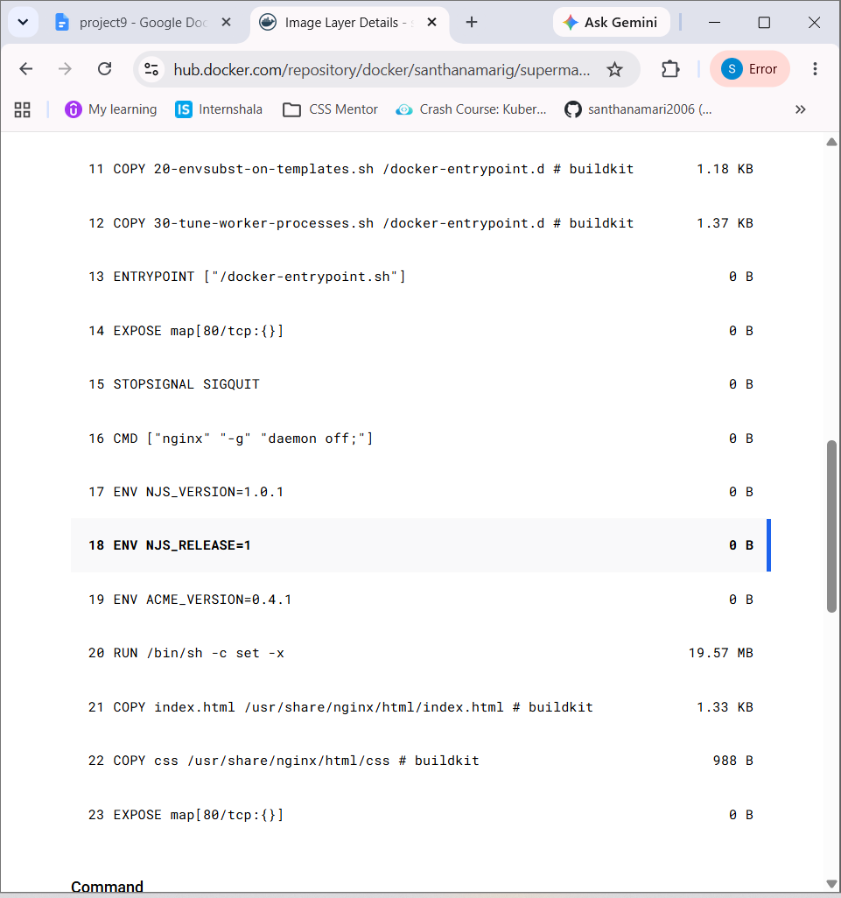

Img push to docker hub

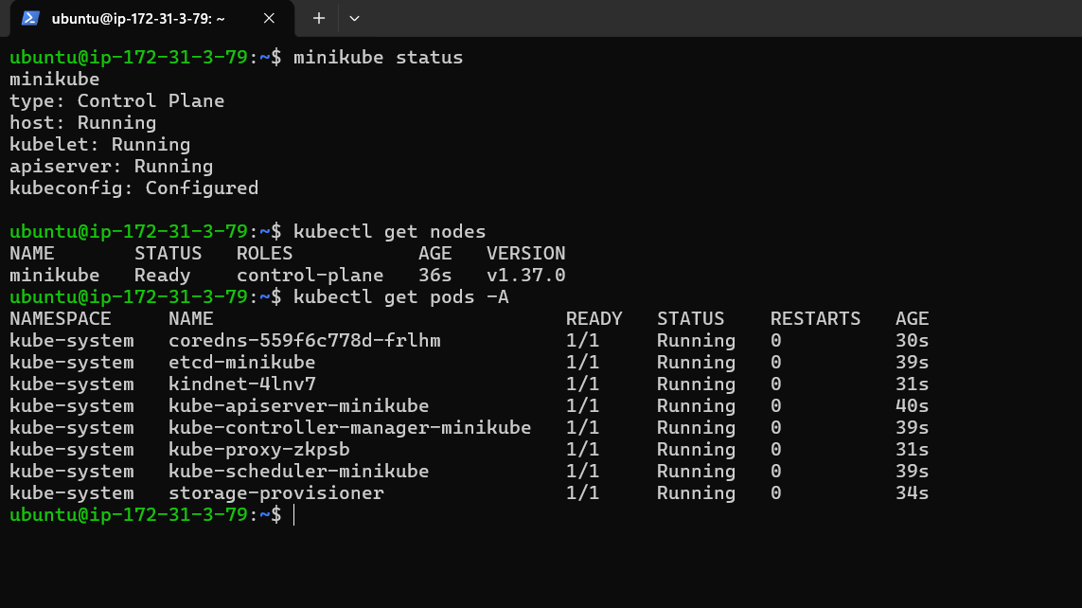

DOCKER

sudo apt update

sudo apt install -y docker.io

sudo systemctl enable --now docker

docker --version

sudo usermod -aG docker $USER => allow ubuntu withour use sudo

sudo usermod -aG docker $USER

newgrp docker

--------------------------------------------

KUBECTL

sudo snap install kubectl --classic

kubectl version --client

--------------------------------------------

MINIKUBE

curl -LO https://storage.googleapis.com/minikube/releases/latest/minikube-linux-amd64

sudo install minikube-linux-amd64 /usr/local/bin/minikube

rm minikube-linux-amd64

minikube start --driver=docker

kubectl get nodes

kubectl get pods -A
—---------------------------------------

apiVersion: apps/v1
kind: Deployment

metadata:
name: devops-app

spec:
replicas: 2

selector:
matchLabels:
app: devops-app

template:
metadata:
labels:
app: devops-app

spec:
containers:
- name: devops-app
image: santhanamarig/supermario:latest
ports:
- containerPort: 80
Deploy.yaml

apiVersion: v1
kind: Service

metadata:
name: devops-app-service

spec:
type: NodePort

selector:
app: devops-app

ports:
- port: 80
targetPort: 80
nodePort: 30080
Service.yaml

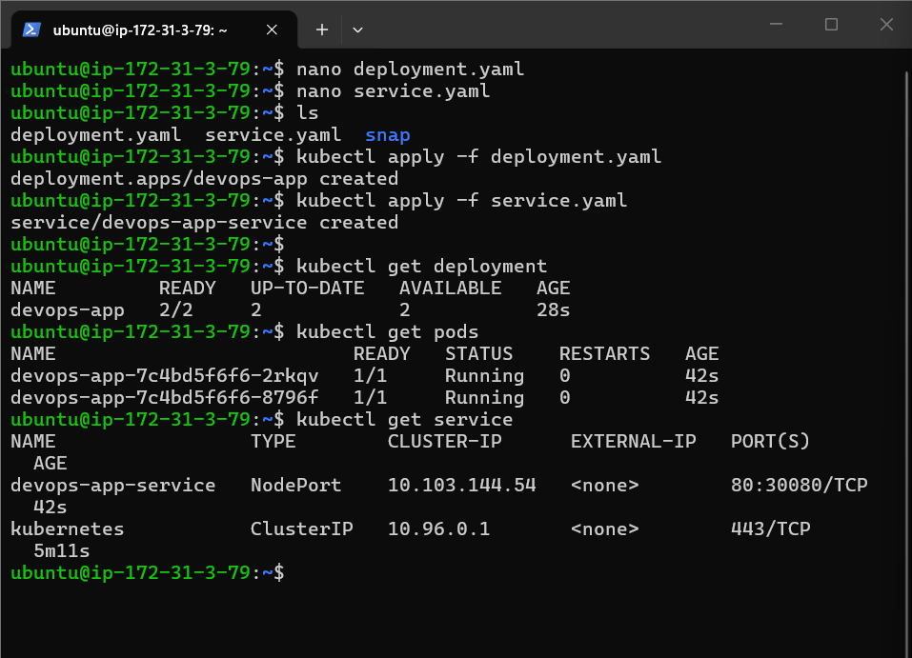

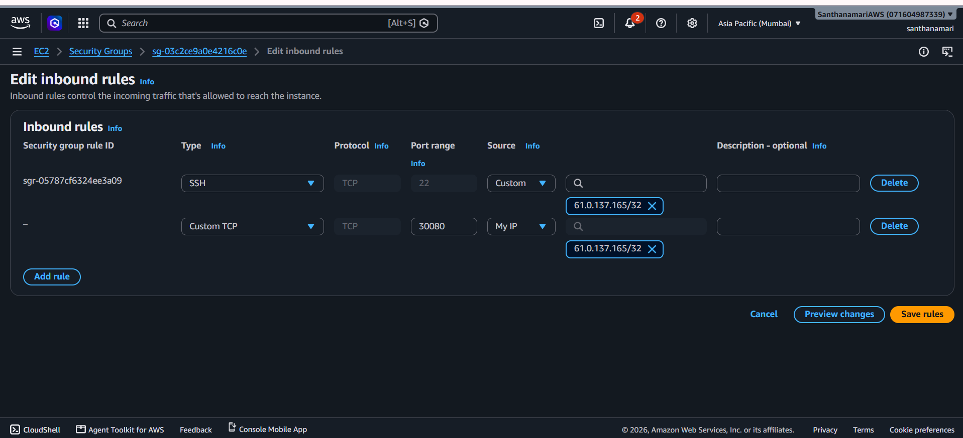

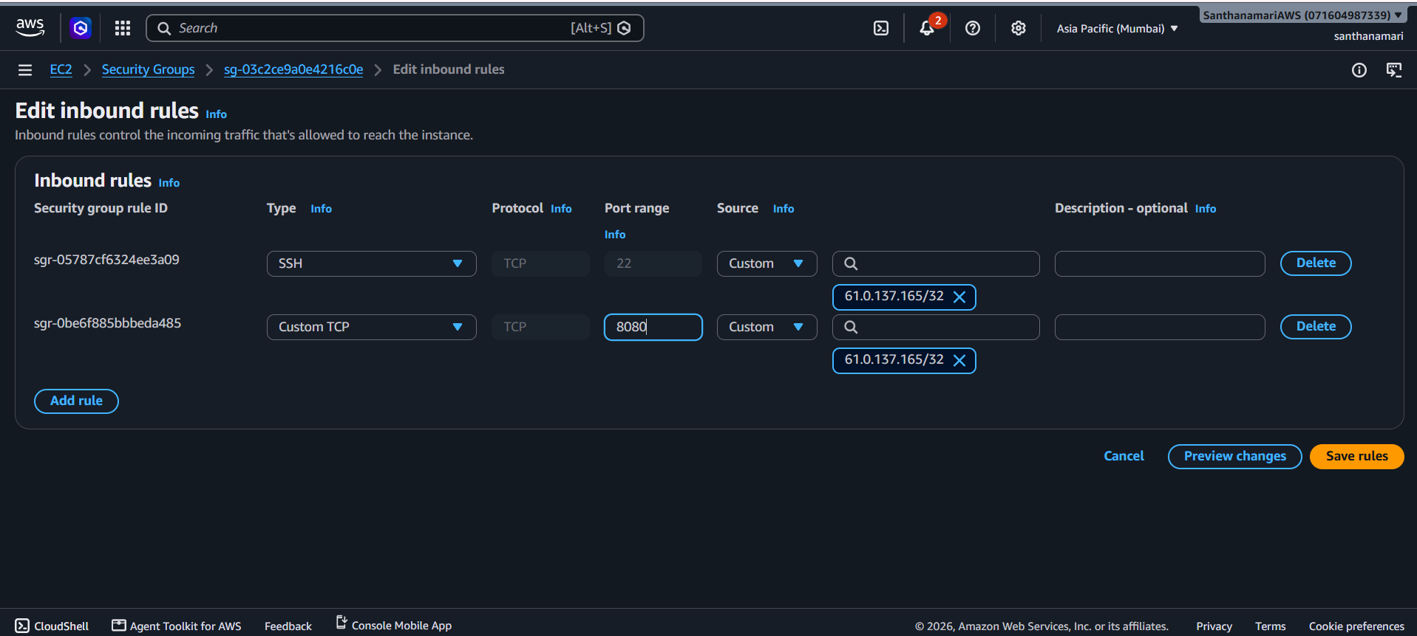

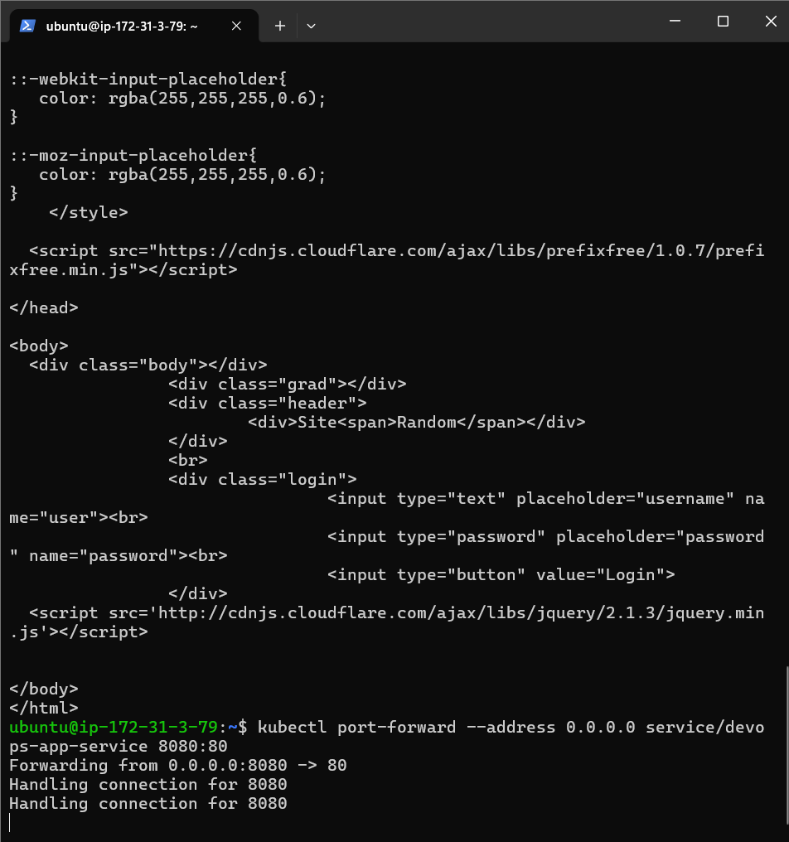

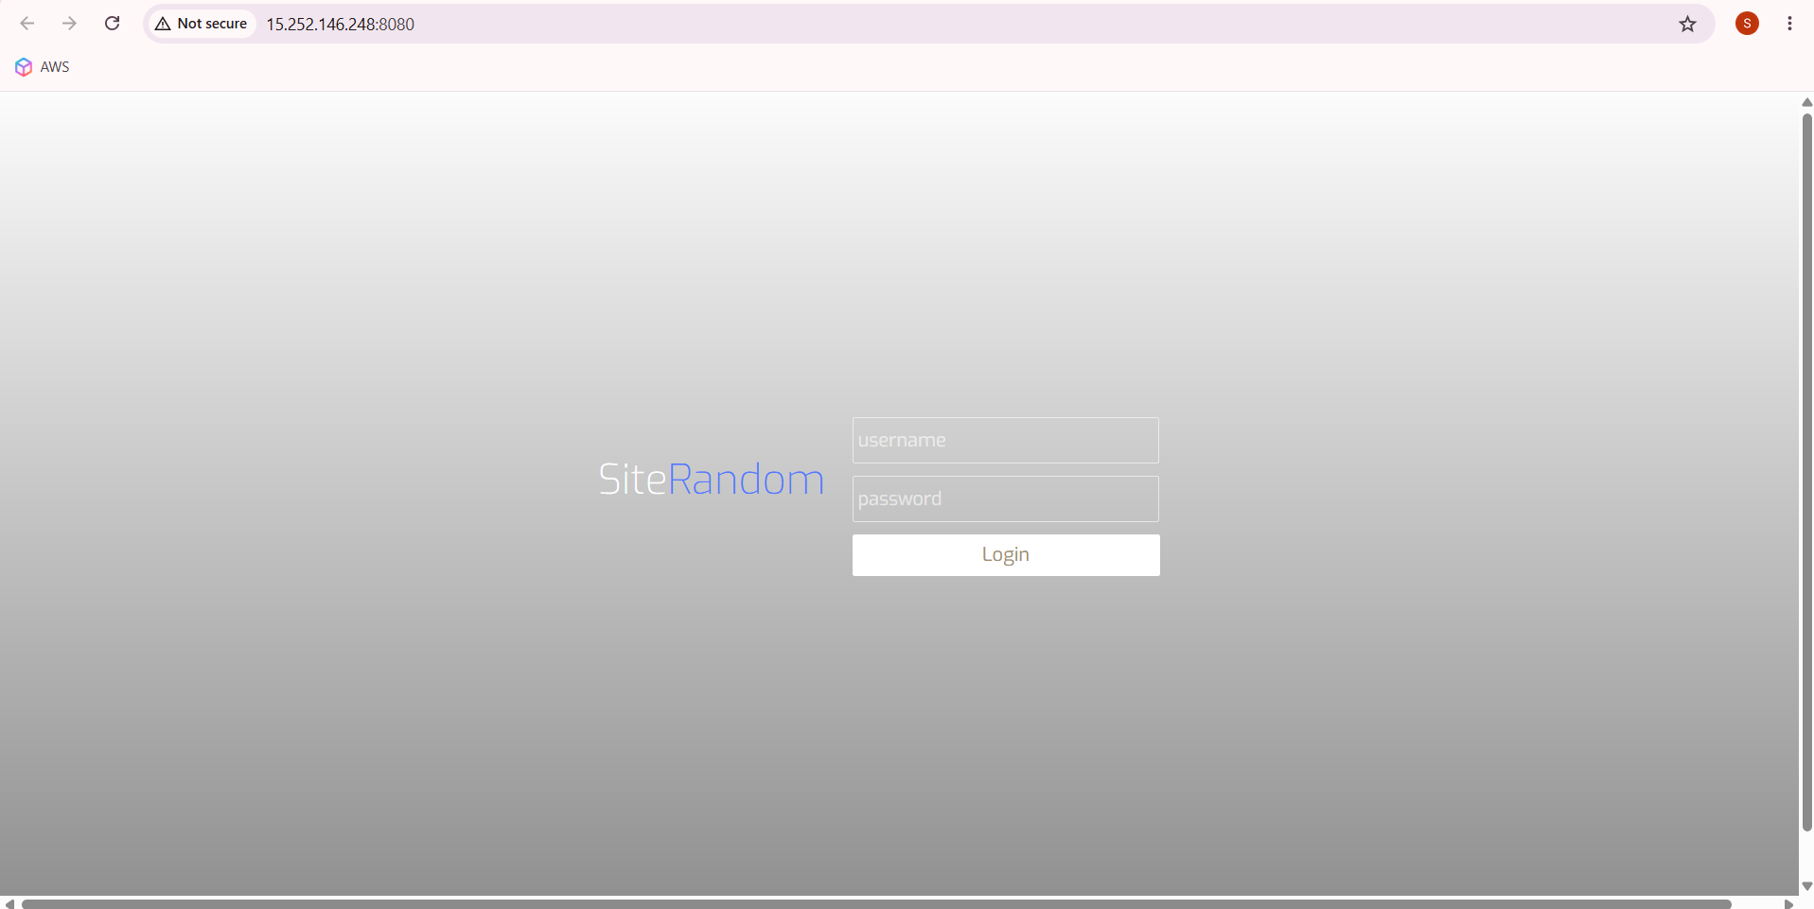

http://15.252.146.248:8080/





